A. Library Websites:
Website | Address | Username | Password
Complete Issues Online | www.completeissues.co.uk | SNHS | SNHS
Independence | www.independence.co.uk | Martin | 31361
The Day | www.theday.co.uk | stniniansdunbarton | theday
B. Using Google – the power of Advanced Search
Remember:
- Most people only look at first page of results
- Top results tend to be sponsored/adverts
- Confirmation bias – don’t stay logged in while searching
- Results only as good as the search you put in
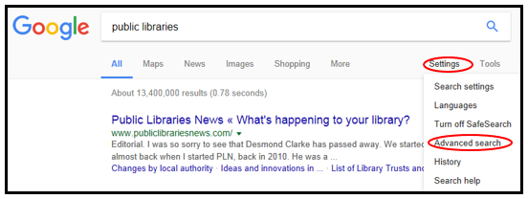

- “This exact word or phrase”
- “None of these words”
- Narrow by “region”
- Narrow by “last update”
- Narrow by “site or domain”

