How to help improve your child’s literacy

- Discuss and review your child’s homework.

- Practise identifying key words and commands in homework questions. Check they understand what the command words are asking them to do. (See attached sheet.)

- Use the correction code (attached) and ensure they understand how to correct their work. Encourage them to proofread their work before submitting it.

- Use online resources where suitable.
Linguascope for Modern Languages
Useful science videos:
BBC Bitesize: https://www.bbc.co.uk/bitesize/levels/z4kw2hv
Veritasium: https://www.youtube.com/channel/UCHnyfMqiRRG1u-2MsSQLbXA
SciShow: https://www.youtube.com/channel/UCHnyfMqiRRG1u-2MsSQLbXA
Absolute Science: https://www.youtube.com/channel/UC4OsMc1sEGwYyoYH_ooaa4A/videos

- Engage in discussion with your child about current affairs. Watch the news together. Encourage them to explore issues which interest them.

- Encourage your child to read as widely as possible: fiction, non-fiction, newspaper articles, in a variety of genres… Encourage them to read beyond for homework. Model reading for pleasure with them. Discuss their reading. (See attached handout.)

Important command words used in Bloom’s Taxonomy
Creating
Develop: expand on or improve by building on initial ideas
Predict: using information you have, work out a likely outcome or ending

Evaluating
Evaluate: give your opinion by exploring the good and bad points. Attempt to support your argument with expert opinion
Assess: estimate or evaluate the value of something
Justify: show something is true or valid using evidence

Analysing
Analyse: Explore the main ideas of the subject, how why they are important and how they are related
Compare and Contrast: Show and discuss the similarities and differences
Examine: Look at something closely

Applying
Demonstrate: show, explain or describe, using information, examples and evidence
Discuss: Explore the subject by looking at its advantages and disadvantages. Attempt to come to some sort of judgement

Understanding
Describe: Give a detailed account
Explain: Describe and make clear, giving reasons and causes
Identify: Recognise or show something as being certain
Summarise: Give the main point of an idea or argument. Leave out unnecessary details
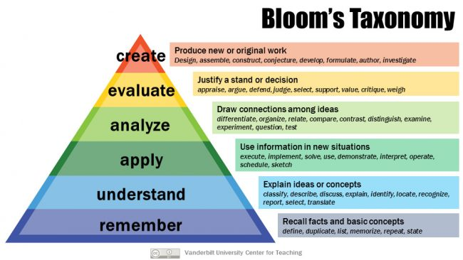
Remembering
List: Give an item by item record of relevant items
Outline: Concentrate on the main bits of the topic or item

