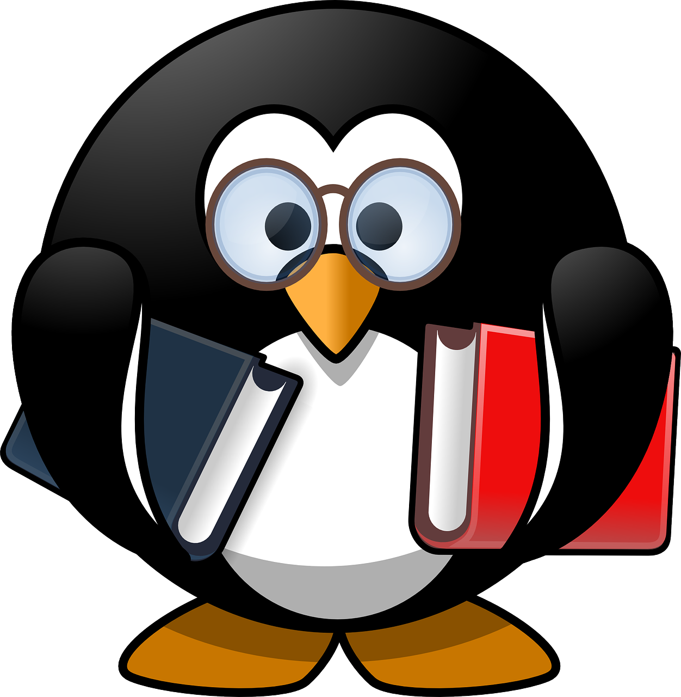

Please ask the librarian for more recommendations. This list is based on our school library collection, with links to free online books while school is closed.
Your local library service will provide free access to eBooks & eAudiobooks. You can join for free in East Dunbartonshire at https://www.edlc.co.uk/libraries/how-join and browse their collections here:
- EDLC Libraries eBooks & eAudiobooks
Titles available to borrow from EDLC Libraries are highlighted in blue.
Follow the library on Twitter @snhs_library to keep up-to-date with all the free content you can access.

Junior & Young Adult Fiction

Boyne, John | The Boy in the Striped Pyjamas. The moving story of a friendship between two boys on either side of a WW2 concentration camp fence.
Bertagna, Julie | The Exodus trilogy. Sci-Fi series set in Glasgow. Thought-provoking look at the consequences of rising sea-levels.
Blackman, Malorie | Noughts and Crosses trilogy. Echoes of Romeo & Juliet which turns racism on its head.
Chbosky, Stephen | The Perks of Being a Wallflower. Coming-of-age tale about outsider Charlie, who discovers the joys of friendship with older students Sam & Patrick. Has scenes which some readers may find upsetting.
Conaghan, Brian | The Bombs that Brought us Together. Compelling story of life as a child in a fictional warzone; friendship against the odds.
Crossan, Sarah | One. The tale of conjoined twins Grace & Tippi who face the challenge of school for the first time as teenagers. Told through poetry – lyrical and moving. Her other verse books are also worth checking out – Moonrise and Toffee especially.
Fraillon, Zara | The Bone Sparrow. The treatment of refugees, seen through the eyes of a boy born and brought up in a detention camp in Australia.
Gaiman, Neil | The Graveyard Book. An original fantasy about life as an outsider. The story follows Bod, raised by the supernatural residents of a graveyard.
Gibbons, Alan | Hate. Based on the real-life murder of teenager Sophie Lancaster, this novel looks at how prejudice against difference can end in tragedy. Powerful and thought-provoking.
Heathfield, Lisa | I Am Not a Number. Present-day. The ultra-conservative Traditional party have won power, and Ruby and her family must now learn to survive in a country where protest is punishable by imprisonment.
Hardinge, Frances | The Lie Tree. Highly original writing which weaves together fantasy and feminism in Victorian times. Winner of Costa Book of the Year 2015.
Landman, Tanya | Buffalo Soldier. Set after the American Civil War, this novel follows Charley after she is set free from slavery. This is a compelling read which questions what it means to be truly free.
Lockhart, E. | We Were Liars: a compelling read with an ending you won’t see coming. Full of secrets and suspense.
McManus, Karen M. | One of Us is Lying. A murder mystery full of twists and turns – five students walk into their Monday afternoon detention but only four make it out.
MacPhail, Cathy | In Between the Lies, loner Abbie is the only one to receive a message from popular Jude after her disappearance. Lots of twists and unique storytelling in the form of text messages and social media posts.
Ness, Patrick | Chaos Walking trilogy. Dystopia which crosses genres of sci-fi and western: page-turning reading. Ness has also written The Rest of Us Just Live Here, a novel which turns the ‘Chosen One’ narrative on its head.
Niven, Jennifer | All the Bright Places. Beautifully written novel which looks at friendship, grief, & teenage mental health. References to suicide.
Pitcher, Anabel | My Sister Lives on the Mantlepiece: attitudes to terrorism and racism, seen through the eyes of a child.
Pullman, Philip | Northern Lights trilogy and The Book of Dust. Fantasy series asking big questions about the universe and our place in it.
Reynolds, Jason | Long Way Down is a novel with a difference: told in verse and set in real time, it tells the story of Will, who is seeking revenge for the murder of his brother.
Rowell, Rainbow | Fangirl and Carry On. A brilliant idea: in Fangirl, we follow Cath as she writes fan-fiction while navigating life at uni – in Carry On, readers can lose themselves in the fan-fiction Cath creates.
Thomas, Angie | The Hate U Give. Winner of the Amnesty International Carnegie Award in 2018, and inspired by the Black Lives Matter movement. This is the story of Starr, and the difficult choices she must make to speak out about the murder of her friend.
Zephaniah, Benjamin | Refugee Boy, Terror Kid, Face. Contemporary UK-based writer covering themes of prejudice, discrimination & displacement.

Senior Fiction

Angelou, Maya | I Know Why the Caged Bird Sings. Autobiography covering the early life of American writer & poet Angelou.
Bradbury, Ray | Fahrenheit 451. Classic tale of censorship and a chilling future where all books are banned.
Dahl, Roald | Collected Short Stories. Macabre and dark, often with a twist in the tale. For senior readers.
Doyle, Roddy | The Commitments. Full of humour and richly observed, this book follows three young unemployed men as they set up a soul band in 1980s Dublin.
Gaiman, Neil | American Gods. Crosses the epics of fantasy, mythology and the great American road trip.
Galloway, Janice | The Trick is to Keep Breathing. A compelling account of the bravery needed to overcome each moment, from a woman desperately waiting out her depression.
Gray, Alasdair | Lanark. Often described as the Scottish Ulysses – a very funny, very serious, combination of dystopia & realism.
Hearn, Lian | The Otori series. Begins with Across the Nightingale Floor. Sweeping fantasy/history trilogy set in the Far East.
Hosseini, Khaled | The Kite Runner. A tale of betrayal, redemption and – above all – friendship, set against the backdrop of 1970s Afghanistan and present-day California.
Kelman, James | The Busconductor Hines. Working-class Glasgow life from a narrator with a vivid imagination.
McEwan, Ian | Atonement. Award-winning novel looking at how one lie alters many lives over many decades.
Morgenstern, Erin | The Night Circus. Fairy tale and fantasy merge in this novel of circuses and magicians.
Morrison, Toni | Beloved. Mother-daughter relationships set against the backdrop of American slavery.
Orwell, George | 1984. Big Brother is watching: the classic dystopian novel of state interference.
Pratchett, Terry | Author of the well-known Discworld fantasy series: books with a lot to say about the world we live in.
Shriver, Lionel | We Need to Talk About Kevin. A school shooting told from the point of view of the killer’s mother.
Tan, Amy | The Joy Luck Club. Mother-daughter relationships in a group of Chinese & Chinese-American women.
Zusak, Markus | The Book Thief. Haunting tale narrated by Death about a girl who learns to love books in the shadow of Nazism.

P. McLean (Librarian)
pmclean@st-ninians.e-dunbarton.sch.uk
May 2020

