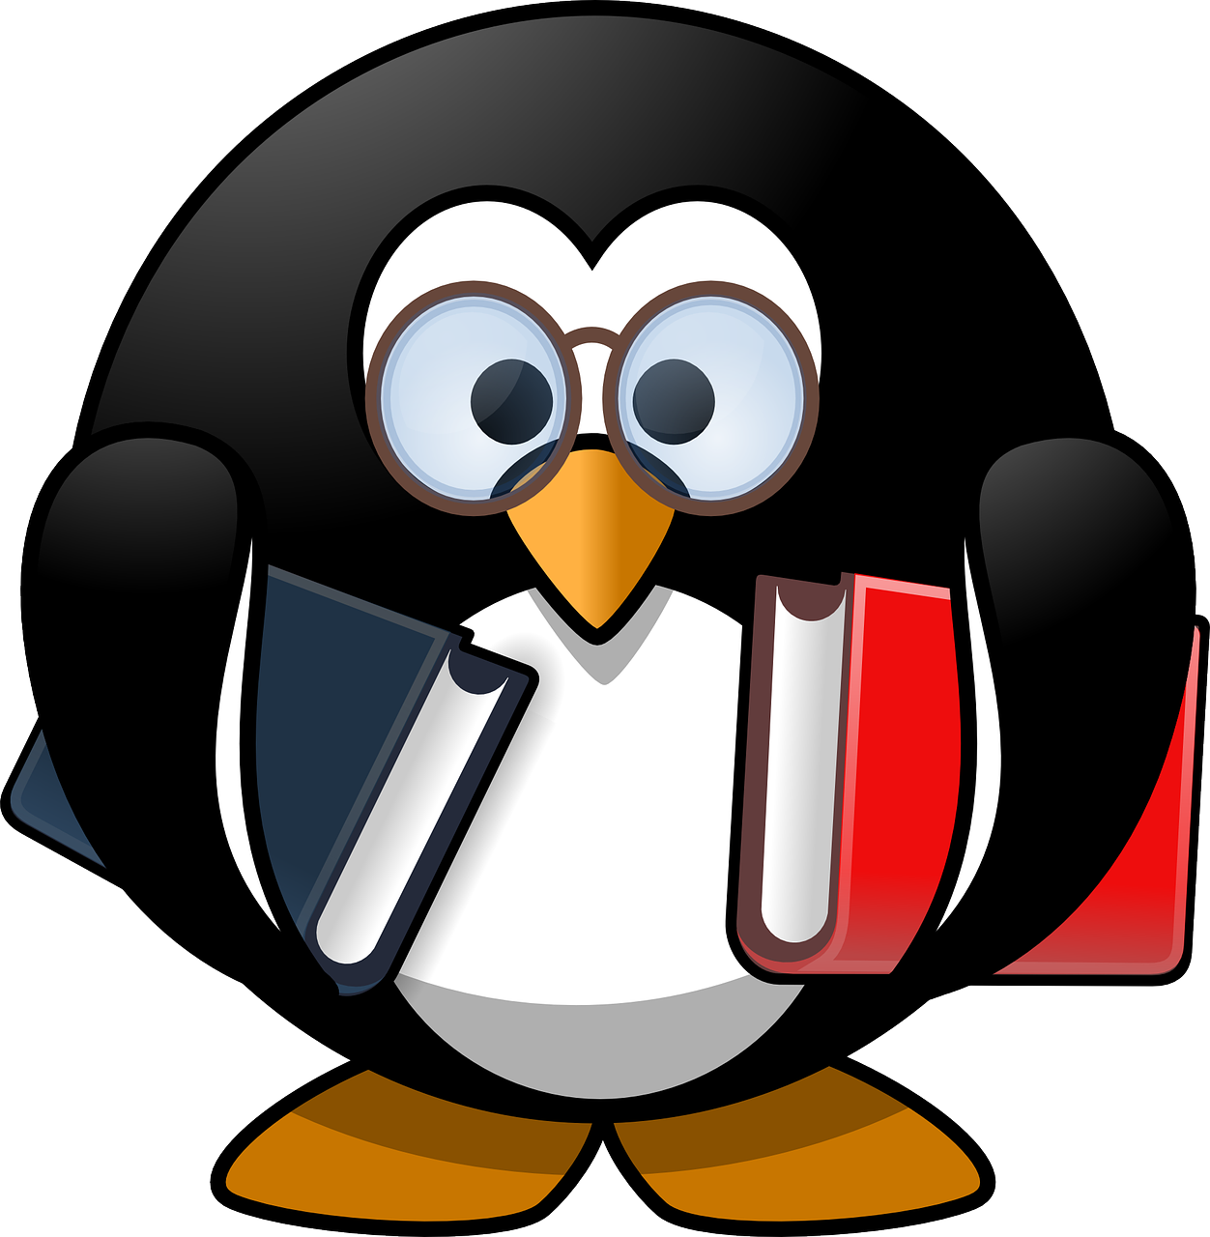

Please ask the librarian for more recommendations. This list is based on our school library collection, with links to free online books while school is closed.
Your local library service will provide free access to eBooks & eAudiobooks. You can join for free in East Dunbartonshire at https://www.edlc.co.uk/libraries/how-join and browse their collections here:
- EDLC Libraries eBooks & eAudiobooks
Titles available to borrow from EDLC Libraries are highlighted in blue.
Follow the library on Twitter @snhs_library to keep up-to-date with all the free content you can access.
Only have 5 minutes? Check out The Book of Hopes from the National Literacy Trust: (very!) short stories, poems & pictures.
Alexander, Kwame | Rebound is a novel in verse about grieving Chuck, who discovers a love of basketball in the aftermath of his father’s death.
Anderson, Sophie | The story of Marinka and her grandmother who live in The House With Chicken Legs is a brilliant retelling of the Baba Yaga myth.
AIUK | Here I Stand. Collection of poems and short stories exploring freedom and human rights. A brilliant collection of genuinely good reads endorsed by Amnesty International.
Blackman, Malorie | Former Children’s Laureate and writer of the Noughts & Crosses trilogy – echoes of Romeo & Juliet which turns racism on its head.
Boyce, Frankie Cottrell | Carnegie-winning author of funny and touching books including Millions, Framed and Sputnik’s Guide to Life.
Breslin, Theresa | Local author whose books have gone down as classics of children’s writing: Divided City (about the friendship between a pair of young Rangers and Celtic fans) is one of our most borrowed books.
Carroll, Emma | Letters from the Lighthouse is set during World War Two, and follows evacuees Olive and Cliff as they try to solve the mystery of their sister’s disappearance.
Cassidy, Anne | Compelling crime – tightly plotted and challenging reads: Looking for JJ and The Murder Notebooks series.
Colfer, Eoin | Gripping fantasy series Artemis Fowl, about the dark side of the fairy world.
Cowell, Cressida | Current Children’s Laureate Cressida Cowell has created a brilliant fantasy in The Wizards of Once, imagining what life might be like in a world where wizards & warriors have been brought up as enemies.
Craig, Joe | Action-packed thrillers starring spy Jimmy Coates – page turners, full of twists and turns.
Cross, Gillian | The Demon Headmaster series, shorter books about the adventures of a group of school friends who find out their headmaster isn’t what he appears to be…
Dashner, James | The Maze Runner, a dystopian adventure series perfect for fans of the Hunger Games – teens wake up in an impossible maze, with no memory of how they got there.
Delaney, Joseph | Spooks series – a fantasy world full of masters, apprentices and fantastic beasts. Perfect for fans of Harry Potter.
Don, Lari | Scottish author of fantastical tales about mythical creatures: First Aid for Faeries and Other Fabled Beasts.
Evans, Lissa | Wed Wabbit is a truly original and funny adventure story about a girl who is plunged into a fantasy world of her own making.
Freedman, Dan | Very popular football books following the ups and downs of teen player Jamie Johnson (the CBBC series Jamie Johnson is based on these books).
Gaiman, Neil | Writes for adults and for children, but his books for children are fast becoming classics, with Coraline and The Graveyard Book among their number. Truly original stories with a fantastical twist.
Gleitzman, Morris | Once, Now, Then and After, a book series set against the backdrop of the Holocaust. Ideal for readers of The Boy in the Striped Pyjamas.
Hargrave, Kiran Millwood | Winner of the Waterstone’s Children’s Book Award in 2017 for The Girl of Ink and Stars, a fantasy adventure set on the island of Joya which follows a girl’s quest to find her missing friend.
Horowitz, Anthony | Horror books that Goosebumps readers can move onto (see Darren Shan for similar reads), as well as the fast-paced thriller series Alex Rider and supernatural fantasy series The Power of Five.
Landy, Derek | Skulduggery Pleasant – supernatural mystery series about a private detective who also happens to be a skeleton.
Lockwood, Vicki | The Magnificent Lizzie Brown series – mystery books set in Victorian times with a supernatural edge. Real page turners!
McCaughrean, Geraldine | Writer of The White Darkness and The Death Defying Pepper Roux, adventure books with daring and original characters taking the lead.
MacKenzie, Ross | Fantastic fantasy series about orphan Daniel and his discovery of The Nowhere Emporium. Spells, witches, heroes and villains abound in his most recent book Evernight.
MacPhail, Cathy | Scottish author of contemporary fiction, following the everyday lives of her characters as they face bullying, girl gangs and peer pressure.
Muchamore, Robert | Very enjoyable and highly readable Cherub series about teen spies who work for British Intelligence.
Oldfield, Tom & Matt | Ultimate Football Heroes. Biographies of famous footballers written in the style of fiction books. Includes players like Messi, Kane and Ronaldo.
Palacio, R.J. | Wonder, a life-affirming and uplifting book about a home-schooled boy with a facial difference who is suddenly thrust into the world of middle school.
Palmer, Tom | Popular football books often crossed with historical or thriller genres.
Pichon, Liz | Writer of the funny and imaginative Tom Gates books. A brilliant combination of words and doodles – perfect for fans of Wimpy Kid.
Pratchett, Terry | Funny fantasy author whose adult fiction series Discworld lends its witch characters to these teen books, including A Hat Full of Sky and The Wee Free Men.
Pullman, Philip | Writer of His Dark Materials and The Book of Dust - highly original fantasy series which asks big questions about the universe, and our place in it.
Raúf, Onjali Q. | The Boy at the Back of the Class is the heart-warming story of a girl who sets out to welcome her new classmate, a refugee from Syria.
Rowling, JK | Harry Potter – the boy-wizard and his friends need no introduction, but it’s worth highlighting that you can borrow the eBooks from your local library.
Riordan, Rick | Writes fantastic fiction based on Greek mythology – Percy Jackson is the most well-known, but there are plenty of other books to discover.
Rundell, Katherine (editor) | The Book of Hopes. Short stories, poems, and pictures from the best authors and illustrators in children’s publishing. Uplifting, optimistic: the perfect escape, even if you only have five minutes.
Sage, Angie | Fantasy adventure series Septimus Heap, perfect for Harry Potter fans looking for more.
Scott, Libby & Westcott, Rebecca | Can You See Me? recounts the elations and frustrations of 11-year-old Tally, who is autistic. The book features the diary entries of 11-year-old author Libby Scott, who is also autistic.
Sepetys, Ruta | Salt to the Sea won the Carnegie Medal in 2017, and tells the story of four young people making their separate ways to the ill-fated ship William Gustloff in World War Two.
Shusterman, Neal | Arc of a Scythe trilogy. In the far future, humans have gained immortality – death can only be granted through a group called scythes. Citra & Rowan are initiated into this mysterious group – Scythe is the start of their journey.
Stevens, Robin | Murder Most Unladylike series. Mysterious murders and a dynamic detective-duo, all set in a boarding school in the 1930s. One of our most popular series!
Stewart, Martin | Scottish-based author whose debut novel Riverkeep follows a boy and his father who make their living from the river – a fantastical take on Glasgow and the Clyde.
Welford, Ross | Funny, page-turning and original stories: try Time Travelling with a Hamster and The Kid Who Came from Space.
Williamson, Victoria | The Fox Girl and the White Gazelle is a beautiful story of friendship and belonging. It also has one of the best openings to a story we’ve read in a while!

Ms McLean (Librarian)
pmclean@st-ninians.e-dunbarton.sch.uk
May 2020

