SNHS Library now has free eBooks for you to download and read from home.
You can borrow books for private reading during English, or to read for fun.

Reading eBooks on a computer:

- Go to https://st-ninians.eplatform.co, click on Sign In and enter your log-in details.
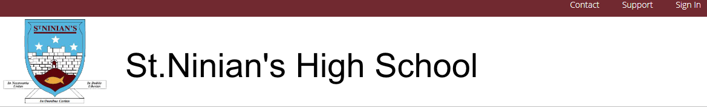

Email Ms McLean if you don’t have your log-in details yet:
pmclean@st-ninians.e-dunbarton.sch.uk

- Change your password by clicking on the arrow to the right of your name:
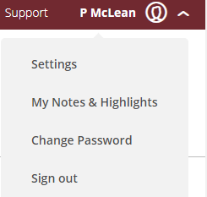

- Click on Browse to see books you can choose from.
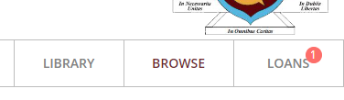

- When you see a book you want to read, click the Borrow button (you can also choose to Look Inside if you want to look inside)

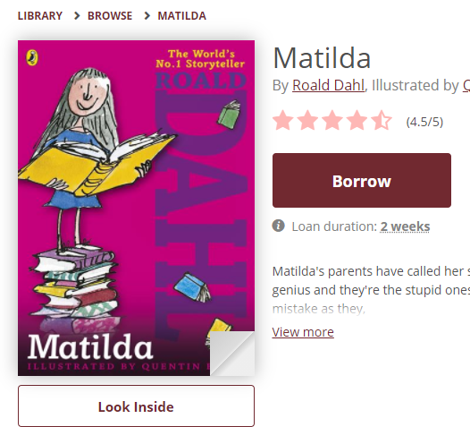

- The book should open on your computer –

You can borrow 2 books at a time, for a maximum of 2 weeks.

Reading eBooks on a tablet or mobile phone:

- Download the ePlatform app (look for it in your app store)

- Open the app and type St Ninian’s Library in the Find Your Library box

- Log in (if you don’t have your log-in yet, contact Ms McLean)

- This will open our eBooks homepage. You can browse the library & borrow a book from here.

More tips:

You can change how a book appears to make it easier to read.

To access this, open an eBook you have borrowed.

- On a computer, these options will be on the top left of the screen.
- On a phone/tablet, tap the middle of a page to bring up your options.
Choose the one that looks like this:
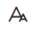

Set & save your preferred font, page colour & line spacing.

Any problems, email Ms McLean at pmclean@st-ninians.e-dunbarton.sch.uk

Happy reading!

