**Audio Recording – Step by Step Process**

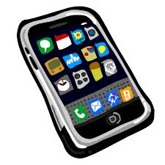

**Keep the facts nice and simple!!**

**This technique is ideal for an auditory learner!!**

**This method is used to record notes and listen to them repeatedly!!**

**Audio Recording – Step by Step Process**



**Keep the facts nice and simple!!**

**This technique is ideal for an auditory learner!!**

**This method is used to record notes to compare them with your sample answer!**