Study Skills
Mnemonics
When we have a lot of information to memorise it can be useful to make up little rhymes or acronyms (words made up of the first letter of each of the words to be remembered). This way you are condensing the information that you need to know into a smaller chunk.
Examples
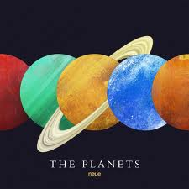
My Mars
Very Venus
Easy Earth
Method Mercury
Just Jupiter
Set Saturn
Up Uranus
Nine Neptune
Planets Pluto

Roy G Biv
Red
Orange
Yellow
Green
Blue
Indigo
Violet

Time to come up with your own…
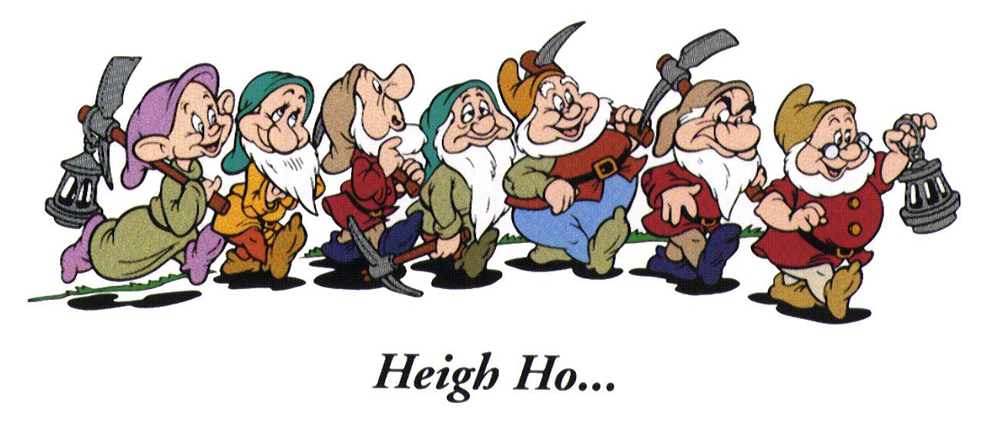
Bashful, Doc, Dopey, Grumpy, Happy, Sleepy and Sneezy.
Putting the dwarves in any order, come up with a mnemonic to help you remember all 7.

What subjects do you think you would be able to create some mnemonics to help you learn your information?

