MIND MAPPING

A mind map is a diagram used to visually outline information.
A good mind map resembles a work of art.

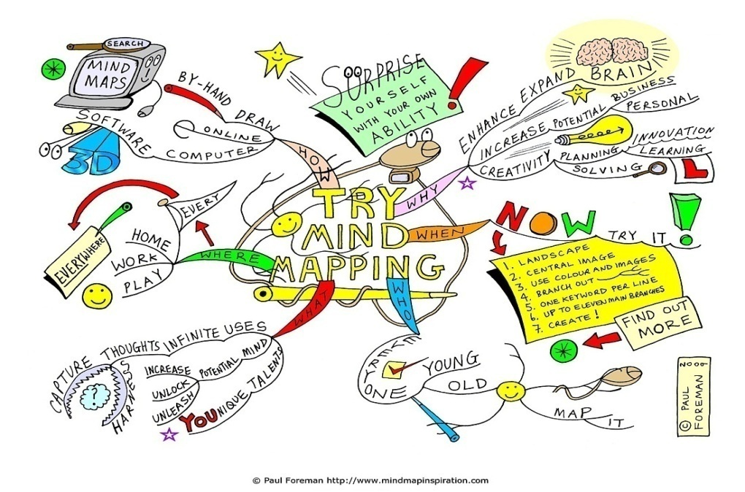

The map is often created round a single word or text to which associated ideas, words and concepts are added.
They are quick to review as you can refresh information form one glance.
Use simple, strong words and colour to separate ideas.

To create your mind map please TURN OVER NOW

Step by step on how to create your mind map

Step 1: Write the title of the subject you wish to study/remember in the centre of your piece of paper and draw a circle around it:
Osmosis

Step 2: As you come across subdivisions of the topic, draw lines out from the centre circle:
Molecules move in and out of cell
Osmosis

Step 3: As you think deeper into these topics and uncover more information, draw lines from the subdivisions:
Molecules move in and out of cell
Osmosis
Cells are semi-permeable
Molecules always in motion

You can make your mind map as simple or as complicated as you want

