Science Skills

Level 3

Reading Scientific Texts

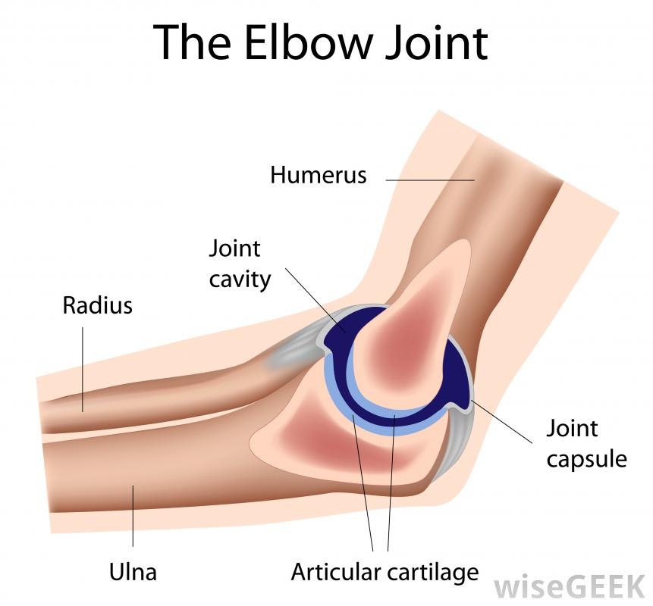

|  |
| --- |
| **Name:**  **Class:** |

**Reading Scientific Texts**

Scientific texts are very like other texts which you read at school.

To answer the questions, you should

1. **Read** through the whole of the **text** first. They are not very long.

2. **Read** all the **questions**.   
When you do this you will realise that the **questions follow the order of the passage.** That is, the answer to the first question is at the beginning of the passage; the answer to the second questions is in the next part of the passage and so on.

3. To write the answers, look for the key words in the question and find them in the passage.   
Highlight them.   
Then read the whole of the sentence they are in. This should give you the answer.  
If you still have not found the answer to the question, read the sentence that goes **before** the key words in the passage and the sentence that comes **after**.

4. Type your answer into the box. The box will expand if you need more room.   
 Short sentences are best.

**Example:**

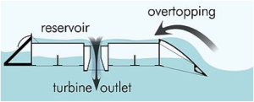 **Tidal Energy**

Tidal power is a form of hydropower that converts the energy of tides into useful forms of power – mainly electricity. Although not yet widely used, tidal

power has potential for future electricity generation.

Tides are more predictable than wind energy and   
 solar power.

(i) Into which form of power is the energy of tides usually converted?

|  |
| --- |
| Energy of tides is usually converted into electricity. |

(ii) Which form of energy is most predictable - wind energy, solar power or tides?

|  |
| --- |
| Tides are more predictable. |

**Passage 1**

**Use the information in the passage to answer the questions.   
Type the answers in the boxes provided.**

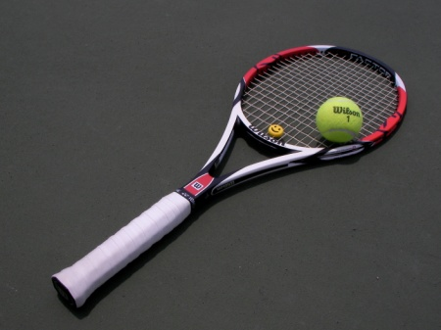The design of tennis racquets has changed over the last hundred years. Early tennis racquets had a solid wooden frame and strings made from animal gut. By the 1930s most racquets were made from layers of wood glued together instead of solid wood. Although this made the racquets a little lighter, they lacked strength.

In the 1960s, metal racquets were introduced. These were stronger and lighter than wooden racquets. At first, the metal used was steel. When racquets with larger heads were introduced, aluminium was used because it is a lighter metal.

Today, tennis players use racquets with stiffer frames to give more control of the ball. The racquets can be made from graphite which is a mixture of carbon fibre and plastic resin. Graphite frames are even stronger and lighter than aluminium frames.

(*a*) Describe **fully** the early tennis racquets.

|  |
| --- |
|  |

(*b*) What advantages do metal racquets have over wooden racquets?

|  |
| --- |
|  |

(*c*) What is graphite?

|  |
| --- |
|  |

**Passage 2**

**Use the information in the passage to answer the questions.  
Type your answers in the boxes provided.**

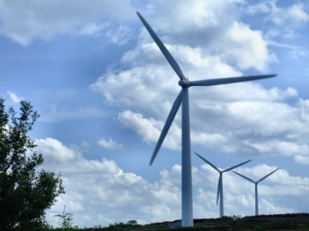Traditional windmills use the power of the wind to turn mill stones and  
drive water pumps. Modern wind turbines also use the power of the wind.  
However, a modern wind turbine turns a generator which produces  
electricity.

The electricity produced by wind turbines goes into the National Grid. The National Grid then carries the electricity to homes and industries throughout Britain.

A 600 kW wind turbine can supply the electricity needed for 400 households. Although wind speeds are always changing, there is usually enough wind to operate the turbine for 70% of the time. A wind turbine is designed to last for about 20 years. However, moving parts such as blades and gearboxes must be regularly maintained to prevent the wind turbine from breaking down.

(*a*) What were traditional windmills used for?

|  |
| --- |
|  |

(*b*) What happens to the electricity after it goes into the National Grid?

|  |
| --- |
|  |

(*c*) How many households can a 600 kW wind turbine supply?

|  |
| --- |
|  |

(*d*) Name **two** parts of a wind turbine that must be regularly maintained.

|  |
| --- |
| 1.  2. |

**Passage 3**

**Use the information in the passage to answer the questions.  
Type your answers in the boxes provided.**

Bees, wasps and termites are social insects. They live in family groups or colonies, and often build large nests. The number of insects in a colony can vary from a few hundred to several million.

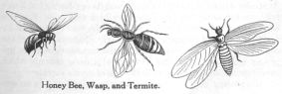Bees use wax to build hexagonal cells in their nests. Wasps build their nests from wood fibres, which they chew to produce a paper-like substance. Termites build large earth mounds which can be up to 6 metres high.

The insects in a colony differ in size and carry out different tasks. The smallest insects are called workers. Workers collect food, look after the young and repair the nest but are unable to reproduce. Larger insects, called soldiers, defend the nest from predators. Only one insect, called the queen, can reproduce. She is much bigger than the other members of the colony and may live for many years. A queen termite can lay up to 30 000 eggs a day and can live for 50 years, which is longer than any other insect.

(*a*) Name **three** types of social insects.

|  |
| --- |
|  |

(*b*) Which type of insect uses wood fibres to build its nest?

|  |
| --- |
|  |

(*c*) List **all** the tasks carried out by worker insects.

|  |
| --- |
|  |

(*d*) Describe **two** ways in which the queen is different from the other insects in a colony.

|  |
| --- |
| 1.  2. |

**Passage 4**

**Use the information in the passage to answer the questions.  
Type your answers in the boxes provided.**

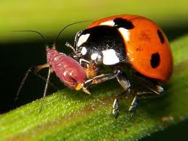

Ladybirds are small, brightly-coloured insects. They are often seen on green plants eating aphids, which are their main prey. Aphids are slow-moving and have no defences so they are easily caught by ladybirds. There are eighty-eight species of ladybird found in Europe. Only forty-three of these species are found in Britain.

A ladybird’s brightly coloured body acts as a warning to animals which might eat it. If attacked, a ladybird defends itself by “reflex bleeding”. This means that blood containing an unpleasant substance called coccinelline oozes from its leg joints. This substance tastes so bad that predators soon learn not to eat ladybirds.

Aphids damage plants, so gardeners use ladybirds as a natural way of controlling the number of aphids. An advantage of using ladybirds to kill aphids is that gardeners do not have to use toxic pesticides. In many European countries, ladybird farms have been set up to provide a supply of ladybirds.

(*a*) Give **two** reasons why aphids are easily caught by ladybirds.

|  |
| --- |
| 1.  2. |

(*b*) How many species of ladybird are found in Britain?

|  |
| --- |
|  |

(*c*) Why does coccinelline stop predators eating ladybirds?

|  |
| --- |
|  |

(*d*) What is the advantage of using ladybirds to kill aphids?

|  |
| --- |
|  |

**Passage 5**

**Use the information in the passage to answer the questions.  
Type your answers in the boxes provided.**

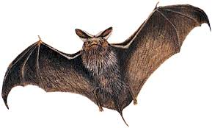  
Bats, like most mammals, have a body covered in fur and give birth to live young. They are different from other mammals, however, because bats are the only mammals which can fly. Their wings are made from webs of skin stretched between long bones, similar to the bones in your hand. The bat’s thumb has a hook on the end which helps it to hang when it is not flying.

Bats are nocturnal. This means that they are active at night. During the day, they roost together, hanging upside down in dark sheltered places.

The most common bat in Scotland is the Pipistrelle. This bat is very small, with a body length of 38 mm, and weighs less than a 2p coin. It flies, twisting and diving, with sudden changes in direction. It snatches gnats, midges and moths from the air. One Pipistrelle can eat up to 3000 of these insects in one night.   
The Long-eared bat is also found in Scotland. It is bigger, with a body length of 50 mm. Its ears are as long as its body. It flies slowly, hovering among branches of trees, grabbing caterpillars, spiders and moths from the leaves.

(*a*) What makes bats different from other mammals?

|  |
| --- |
|  |

(*b*) What do bats do during the day?

|  |
| --- |
|  |

(*c*) What length are the ears of a Long-eared bat?

|  |
| --- |
| mm |

(*d*) Which insect do both the Pipistrelle and the Long-eared bat eat?

|  |
| --- |
|  |

**Passage 6**

**Use the information in the passage to answer the questions.  
Type your answers in the boxes provided.**

Humans can hear sounds between 20 Hertz (a low-pitched sound) and 20 000 Hertz (a high-pitched sound). This means that the human hearing range is 20 to 20 000 Hertz.

The hearing ranges of other animals are different from that of humans. Some animals can hear sounds which are too high-pitched for humans to hear. These are called ultrasonic sounds. For example, a dog whistle is easily heard by a dog but not by humans because the sound that the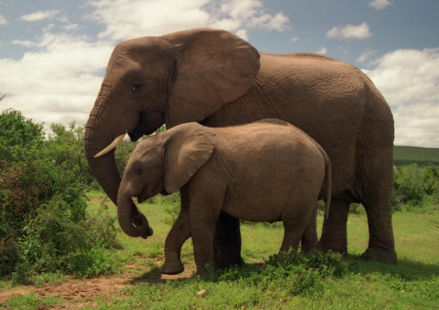 whistle makes is too high-pitched.

Other animals can hear sounds that are too low-pitched for humans to hear. About 65% of the noises an elephant makes are pitched below the human hearing range. Elephants make low rumbling sounds that can be heard by other elephants up to 5 kilometres away.

(*a*) What is the human hearing range?

|  |
| --- |
| to Hertz |

(*b*) What name is given to sounds which are too high-pitched for humans to hear?

|  |
| --- |
|  |

(*c*) Why can humans not hear a dog whistle?

|  |
| --- |
|  |

(*d*) From what distance can elephants hear the low rumbling sounds made by other elephants?

|  |
| --- |
|  |

**Passage 7**

**Use the information in the passage to answer the questions.  
Type your answers in the boxes provided.**

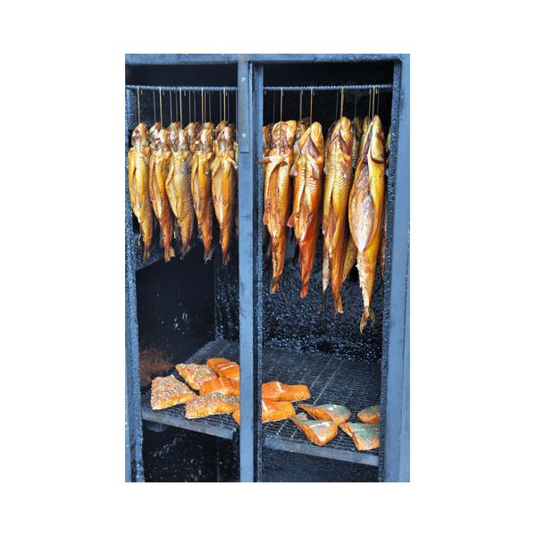All additives used in foodstuffs must be safe. Many foods go off quickly without the use of preservatives. It is now known that preservatives prevent the growth of micro-organisms, some of which are extremely dangerous.

Most preservatives are simple chemicals and are closely related to natural substances. For example, benzoic acid occurs in several fruits and is widely used in fruit preservation. Sorbic acid, another preservative, is an unsaturated acid found in some plants.

Some preservatives have been used for hundreds of years. For example wood smoke is used to preserve fish. However, wood smoke contains a large number of hydrocarbons, some of which cause cancer.

Adapted from *In the Mix* by Food Additives and Ingredients Association.

(*a*) Why are preservatives added to food?

|  |
| --- |
|  |

(*b*) Name the unsaturated acid found in some plants.

|  |
| --- |
|  |

(*c*) Which compounds present in wood smoke may cause cancer?

|  |
| --- |
|  |

**Passage 8**

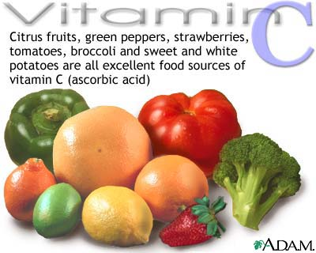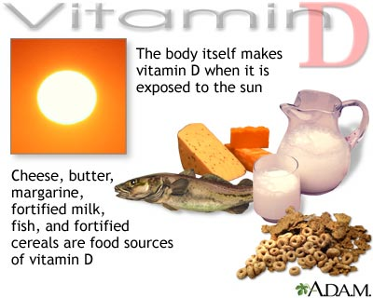**Use the information in the passage to answer the questions.  
Type your answers in the boxes provided.**

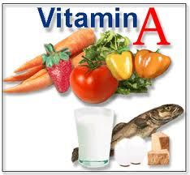

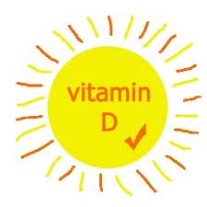**Vitamin D** is needed by people to strengthen their bones. Sunlight isneeded for the body to make **vitamin D**. **Vitamin D** is also found indairy products.

**Vitamin A** is important for our eyes. It protects their surface and helps us see in dim light. The best source of **vitamin A** is fish liver oil. The body can also get **vitamin A** by eating carrots – the orange substance in carrots (called carotene) is turned into **vitamin A** by the body.

Scurvy, a skin disease, is caused by a lack of **vitamin C**. **Vitamin C** is found in green vegetables and citrus fruits such as lemons and limes.

**Vitamin B2**, which is found in dairy products, is also needed for healthy skin.

(i) Use the information above to complete the following key by entering the names of the vitamins in the correct boxes.



**Passage 9**

**Use the information in the passage to answer the questions.  
Type your answers in the boxes provided.**



**What’s in a Washing Powder?**

Modern washing powders contain a number of chemicals which reflect the complexdemands of modern living. These detergents must remove stains withoutdamaging fabrics and washing machines. They should also be environmentallyfriendly.

Most detergents contain surfactants which allow the water to spread across the fabric and builders to soften the water. In addition, lather control agents are put in to stop too much froth forming. The pleasant smell of detergents is produced by fragrances. Corrosion inhibitors protect the washing machine from rusting.

Biological washing powders also contain several types of enzyme such as proteases, amylases and lipases. These enzymes are so powerful that the powders have only 1% enzymes.

**Answer the questions below,** using information from the passage.

(*a*) Name the chemical in washing powders which prevents too much froth forming.

|  |
| --- |
|  |

(*b*) Why are “builders” added to washing powders?

|  |
| --- |
|  |

(*c*) Why do biological washing powders contain a very low percentage of enzymes?

|  |
| --- |
|  |

(*d*) Name an enzyme found in biological washing powders.

|  |
| --- |
|  |

**Passage 10**

**Use the information in the passage to answer the questions.  
Type your answers in the boxes provided.**

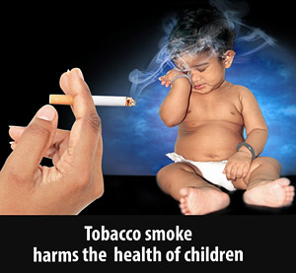 **Second-hand Tobacco Smoke**

Second-hand tobacco smoke is the smoke breathed in by non-smokers when otherpeople are smoking. It is sometimes called environmental tobacco smoke andbreathing it in is known as passive smoking. Only 1 in 5 of the population smokesbut almost everyone breathes in second-hand tobacco smoke at times.

Most non-smokers dislike second-hand tobacco smoke. They complain that it causes headaches, coughs, feelings of dizziness and sickness. It can also cause irritation of the nose, throat and eyes. The smell of tobacco smoke clings to hair, clothes and furnishings.

A burning cigarette is like a mini chemical factory. The smoke contains thousands of chemicals. The smoker breathes in only 15 percent of the smoke from a cigarette. This is called mainstream smoke. The other 85 percent, known as side-stream smoke, goes straight into the air. Side-stream smoke is unfiltered and contains higher concentrations of toxic chemicals than mainstream smoke.

**Use information from the passage to answer the questions below.**

(i) What name is given to breathing in second-hand smoke?

|  |
| --- |
|  |

(ii) Name **two** effects that second-hand smoke has on non-smokers.

|  |
| --- |
| 1.  2. |

(iii) What percentage of smoke from a cigarette is mainstream smoke?

|  |
| --- |
|  |

(iv) Why is side-stream smoke more dangerous than mainstream smoke?

|  |
| --- |
|  |

(*v*) Name a harmful chemical found in tobacco smoke.

|  |
| --- |
|  |

**Passage 11**

**Use the information in the passage to answer the questions.  
Type your answers in the boxes provided.**

**What’s in a drink?**

(Adapted from “Alcohol Focus Scotland” leaflets)

Alcohol is so widely used that we sometimes forget the harm it can cause to our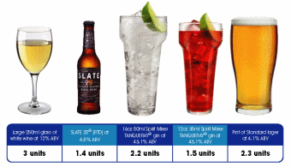 physical and mental health. Adults are advised to drink no more than the following sensible limits.

Men should not drink more than three or four units a day and no more than twenty-one units in one week. The sensible limits for women are two to three units a day with a maximum of fourteen units in one week. In addition, it is advised that everyone needs at least two days a week without alcohol.

An adult body can break down one unit of alcohol in one hour.

The table below shows the number of units in some common drinks.



Use the information **from the passage and table** to answer the following questions.

(i) What is the maximum number of units of alcohol recommended for women in one week?

|  |
| --- |
|  |



(ii) Tick (✓) the correct box to show whether **each** person drinks more than or less than the sensible limit.

**Passage 12**

**Use the information in the passage to answer the questions.  
Type your answers in the boxes provided.**

**Soil**

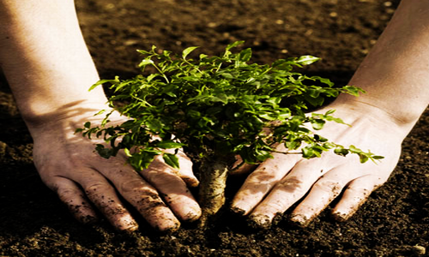Different areas of the country have different types of soil. Some areas have clay soil which is heavy to dig, is made of small particles and has a high mineral content. It drains poorly and can easily become waterlogged and it has low air content.

Other areas have sandy soil which has large particles and a low mineral content. It is light to dig, has high air content and drains freely.

Loam soil is also found in some areas. Loam has medium-sized particles, is easy to dig, is rich in organic matter and minerals and has good air content. It doesn’t drain too quickly, or become waterlogged.

Use information **in the passage** to answer the following questions.

(i) Complete the table below.

|  |  |  |  |
| --- | --- | --- | --- |
| **Type of Soil** | **Ease of Digging** | **Air Content** |  |
| clay |  | low | small |
|  | easy | good | medium sized |
|  | light |  |  |

(ii) Which type of soil becomes easily waterlogged?

|  |
| --- |
|  |

(iii) Compare the mineral content of clay soil with that of sandy soil.

|  |
| --- |
| The mineral content of clay is  The mineral content of sandy soil is |

**Passage 13**

**Use the information in the passage to answer the questions.  
Type your answers in the boxes provided.**

**Meat for Veggies?**

Adapted from *Metro*, Thursday 15 January 2009

Mycoprotein, the unique ingredient in meat substitute products, can play a valuable role in helping overweight people to reduce the levels of fat and calories in their diets. This protein-rich fungus was first used as an ingredient for meat-free pies but is now found in a wide range of vegetarian foods.

The fungus is grown in large tanks called fermenters as shown in the diagram. Oxygen, glucose, vitamins and minerals are supplied to help growth.

Fungus is then harvested, the mycoprotein is extracted and then passed through a heat treatment stage.

Heat treatment prevents the formation of uric acid which can lead to a painful condition called gout.

Finally, the mycoprotein is textured into products which look like chunks of beef or mince, chicken breasts, meatballs or turkey roasts.

**Use the information in the passage to answer the following questions.**

(i) Why can mycoprotein be recommended as part of the diet of overweight people?

|  |
| --- |
|  |

(ii) Name the condition which can be caused by uric acid.

|  |
| --- |
|  |

(iii) Name **two** products that mycoprotein can be made to look like.

|  |
| --- |
| 1  2 |

**Passage 14**

**Use the information in the passage to answer the questions.  
Type your answers in the boxes provided.**

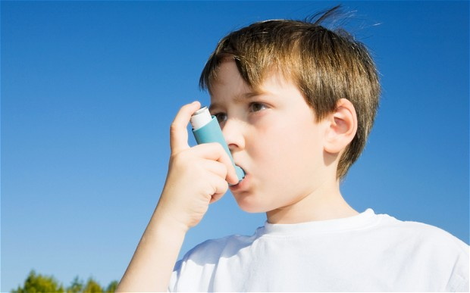

**Asthma – What are the Symptoms?**

Asthma can occur with one or more of four main symptoms: wheezing, cough, chest-tightness and breathlessness. The most well-recognised symptoms of asthma are wheezing and breathlessness. Asthma can sometimes occur for no obvious reason.

One symptom, often not recognised as being caused by asthma, is a cough. This can result in a diagnosis of bronchitis. Bronchitis is usually treated by antibiotics which is not an appropriate treatment for asthma.

In older patients, chest-tightness can occur during exercise. This is often diagnosed as angina when, in fact, it may have been caused by asthma.

An asthma attack can wake patients and this is often a problem in the morning. Waking at night with an asthma attack may mean that the treatment is not working effectively.

Children with asthma frequently find that exercise can trigger an attack. However, if the asthma is properly controlled, it should not be a barrier to sports and other activities.

Use the information **from the passage** to answer the following questions.

(i) Name the **two** most well-recognised symptoms of asthma.

|  |
| --- |
|  |

(ii) Which symptom of asthma can be mistaken for angina?

|  |
| --- |
|  |

(iii) What could waking at night with an asthma attack indicate?

|  |
| --- |
|  |