Science Skills

Level 4

Reading Scientific Texts

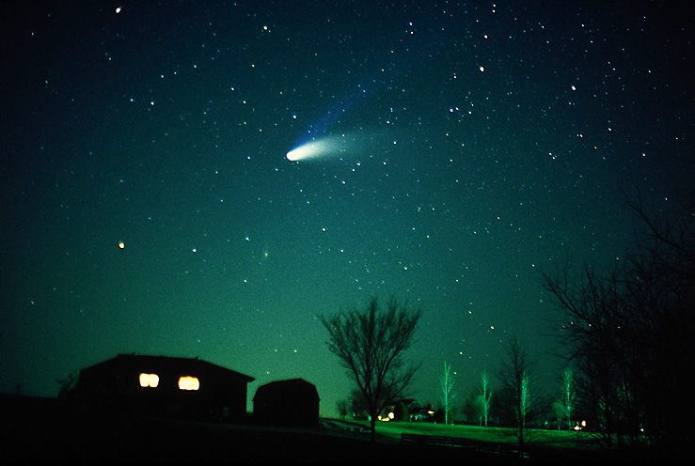

|  |
| --- |
| **Name:**  **Class:** |

**Reading Scientific Texts**

Scientific texts are very like other texts which you read at school. At Level 4 they are longer and the language is more ‘scientific’ than at Level 3. The method of answering, however, is the same.

To answer the questions, you should

1. **Read** through the whole of the **text** first. They are not very long.

2. **Read** all the **questions**.   
When you do this you will realise that the **questions follow the order of the passage.** That is, the answer to the first question is at the beginning of the passage; the answer to the second questions is in the next part of the passage and so on.

3. To write the answers, look for the key words in the question and find them in the passage.   
Highlight them.   
Then read the whole of the sentence they are in. This should give you the answer.  
If you still have not found the answer to the question, read the sentence that goes **before** the key words in the passage and the sentence that comes **after**.

4. Type your answer into the box. The box will expand if you need more room.   
 Short sentences are best.

**Example:**

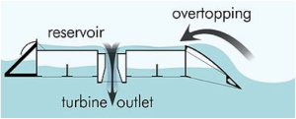 **Tidal Energy**

Tidal power is a form of hydropower that converts the energy of tides into useful forms of power – mainly electricity. Although not yet widely used, tidal

power has potential for future electricity generation.

Tides are more predictable than wind energy and   
 solar power.

(i) Into which form of power is the energy of tides usually converted?

|  |
| --- |
| Energy of tides is usually converted into electricity. |

(ii) Which form of energy is most predictable - wind energy, solar power or tides?

|  |
| --- |
| Tides are more predictable. |

**Passage 1**

**Use the information in the passage to answer the questions.  
Type your answers in the boxes provided****.**

Loft insulation is an effective way of keeping houses warmer and reducing heating costs. Up to 20% of heating costs can be saved by installing effective loft insulation.

The three main types of loft insulation are blown insulation, blanket insulation and loose-fill insulation. Blanket and loose-fill insulation can be easily installed, but blown insulation must be installed by a specialist contractor.

Most houses have blanket insulation. Blanket insulation can be made from mineral fibre or rock fibre and is supplied in rolls. Mineral fibre and rock fibre are non-flammable but must be treated to protect them from rot, vermin and dampness. When installing blanket insulation, protective clothing including gloves and a face mask must be worn to prevent fibres damaging skin and lungs.

Loose-fill insulation can be made from cork granules, vermiculite or cellulose fibre. This type of insulation is not advised for use in a draughty loft because the material can blow about.

(*a*) How much can heating costs be reduced by installing effective loft insulation?

|  |
| --- |
|  |

(*b*) Which type of insulation must be installed by a specialist contractor?

|  |
| --- |
|  |

(*c*) Why must protective clothing be worn when installing blanket insulation?

|  |
| --- |
|  |

(*d*) Why should loose-fill insulation **not** be used in a draughty loft?

|  |
| --- |
|  |

**Passage 2**

**Use the information in the passage to answer the questions.  
Type your answers in the boxes provided.**Many people suffer from painful hip joints. Cartilage in the joint wears away to expose nerve endings and this makes movement painful. In severe cases, the joint can be replaced with an artificial hip.

The materials used to make artificial hip joints must be resistant to corrosion, degradation and wear. They must also have similar mechanical properties to bone. For example, the materials must be strong enough to take the person’s weight and must be able to bear stress without fracturing.

There are no materials that perfectly match the mechanical properties of bone. Metals are strong and have good resistance to fractures but are not flexible enough. Ceramics are strong but have poor resistance to fractures. Polymers have the correct flexibility and good resistance to fractures but are not strong enough. An artificial hip joint is made from a combination of these materials. This gives the best range of properties.

New polymers are being developed which are stronger and even more resistant to fractures. They are also highly resistant to wear. This means that artificial hip joints made from these new polymers last longer and are less likely to need replacing.

(*a*) What happens in a hip joint to make movement painful?

|  |
| --- |
|  |

(*b*) The materials used to make artificial hips must be resistant to degradation.   
 What else must they be resistant to?

|  |
| --- |
| 1  2 |

(*c*) Give a **disadvantage** of using metals and ceramics in artificial hip joints.

|  |
| --- |
| Metals  Ceramics |

(*d*) Explain **fully** why artificial hip joints made from **new** polymers last longer.

|  |
| --- |
|  |

**Passage 3**

**Use the information in the passage to answer the questions.  
Type your answers in the boxes provided.**

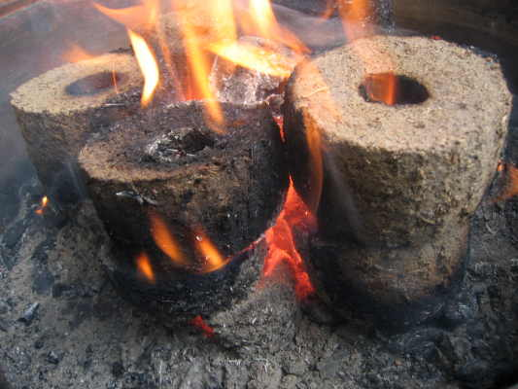  
Biomass fuel is the name given to renewable fuels obtained from living things. The most commonly used biomass fuel is wood. In many parts of the world, wood is the main fuel used for domestic heating and cooking.

Charcoal and wood-alcohol are biomass fuels made from wood. Charcoal can be used in solid fuel heaters, while wood-alcohol is used as a liquid fuel. Charcoal is produced by heating wood in the absence of air. This process is called destructive distillation. The process also produces a mixture of gases which can be condensed to form an oily liquid. Wood-alcohol is obtained from this liquid.

Sugar cane can be used to produce another liquid biomass fuel called ethanol. Sugar, which is extracted from sugar cane plants, is converted to ethanol by the process of fermentation. Ethanol can be burned to produce heat energy or used in a fuel cell to produce electrical energy.

(*a*) What is the most commonly used biomass fuel?

|  |
| --- |
|  |

(*b*) Describe how charcoal is produced.

|  |
| --- |
|  |

(*c*) What happens during the process of fermentation?

|  |
| --- |
|  |

(*d*) Name **two** liquid biomass fuels.

|  |
| --- |
| 1  2 |

**Passage 4**

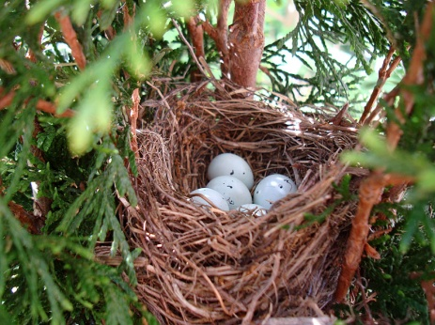**Use the information in the passage to answer the questions.  
Type your answers in the boxes provided.**

Different types of birds lay eggs of different size and shape. Small eggs hatch quickly but the chicks are blind and helpless. Big eggs take longer to hatch but the chicks are covered in down and can soon run about.

Eggs which take longer to hatch are larger because more food is stored for the developing chick. Ravens nest in tree tops and lay small eggs which hatch in 18 days. Curlews nest on open ground and lay bigger eggs which hatch in 28 days. Curlew chicks can quickly be led away to a safer place.

The shape of eggs can be round or pointed. Shore birds nest on the sand and lay four eggs with pointed ends. The eggs lie with their pointed end towards the centre of the nest. This means that the eggs take up less space, the nest is small and the parent birds can easily keep the eggs warm. Fulmars lay one very pointed egg on a bare cliff ledge. If the egg is knocked, it rolls round in an arc rather than rolling off the ledge.

Egg shells contain calcium. As the chick develops inside the egg, some of the calcium is used to help the chick’s bones grow. After hatching, the mother may eat the shell to replace some of the calcium her body lost in making the egg.

(*a*) Describe the chicks which hatch from small eggs.

|  |
| --- |
|  |

(*b*) Why must eggs which take longer to hatch be larger?

|  |
| --- |
|  |

(*c*) Describe **fully** why shore birds lay eggs which lie with their pointed end towards the  
 centre of the nest.

|  |
| --- |
|  |

(*d*) Give **one** use of the calcium in the egg shell.

|  |
| --- |
|  |

**Passage 5**

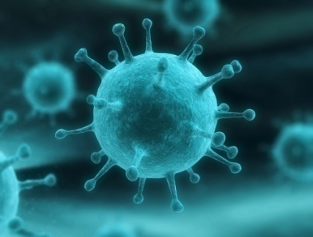**Use the information in the passage to answer the questions.  
Type your answers in the boxes provided.**

Influenza, also known as flu, is a highly infectious disease caused by a virus. The virus can be spread by an infected person coughing and sneezing.

The incubation period is the time between a person catching a virus and starting to show symptoms. The incubation period for flu is between one and three days. A person can start spreading the virus one day before they start feeling unwell and can continue to pass it on for another three to seven days after.

Common symptoms of flu are fever, headaches and aching muscles. Most people recover from flu within a week but some people develop serious complications and require hospital treatment.

A vaccination is offered to people who are most at risk from flu, including the elderly and those with chronic heart or lung disease. The flu vaccine, which helps the body fight infection, is given as an injection in the arm.

However, the flu virus continually changes and new vaccines must be developed each year.

(*a*) How can the flu virus be spread?

|  |
| --- |
|  |

(*b*) How long is the incubation period for flu?

|  |
| --- |
|  |

(*c*) What are the common symptoms of flu?

|  |
| --- |
| 1  2 |

(*d*) Which people are most at risk from flu?

|  |
| --- |
| 1  2 |

(*e*) Why do new flu vaccines have to be developed each year?

|  |
| --- |
|  |

**Passage 6**

**Use the information in the passage to answer the questions.  
Type your answers in the boxes provided.**

The crash helmets used in motor racing provide maximum protection for the driver’s head and increase the aerodynamic performance of the car. They must be designed and manufactured to a higher specification than standard helmets. For example, a motor racing helmet is made from seventeen layers of different materials but a standard helmet has only three layers.

Carbon fibre layers are used to make motor racing helmets rigid and light. This minimises stress on the driver’s neck. Kevlar layers make the helmet fireproof and polyethylene layers provide protection from impact. Aluminium and titanium layers reinforce the helmet and epoxy resin bonds the layers together.

The helmet has a ventilation system, with a filter which removes oil, carbon and brake dust particles from the air. The visor is 3mm thick and is made from fireproof polycarbonate. It has a chemical tint which automatically adjusts to changing light levels so that the driver is unaffected by the glare of the sun.

The helmet also contains a radio which allows the driver to communicate with his team.

(*a*) How many layers are there in a motor racing helmet?

|  |
| --- |
|  |

(*b*) Why must the helmet be rigid and light?

|  |
| --- |
|  |

(*c*) Which material provides protection from impact?

|  |
| --- |
|  |

(*d*) Name **all** the substances filtered from the air by the ventilation system.

|  |
| --- |
|  |

(*e*) Why does the visor have a chemical tint?

|  |
| --- |
|  |

**Passage 7**

**Read the following passage and answer the question based on it.**

The spacecraft will use a new kind of engine called an ion drive. The ion drive will propel the spacecraft away from Earth on its journey to the moons of Jupiter, although for much of the journey the engine will be switched off.

The spacecraft will first visit the moon Callisto. Callisto is only slightly smaller than the planet Mercury. Next, the spacecraft will visit Ganymede, the largest moon in the Solar System, before travelling on to Europa.

The radiation around Europa is so intense that the spacecraft will not be able to operate for long before becoming damaged beyond repair. The spacecraft will eventually burn up in the atmosphere of Jupiter.

(i) Name one object, **mentioned in the passage**, which orbits a planet.

|  |
| --- |
|  |

**Passage 8**

**Read the following passage and answer the question based on it.**

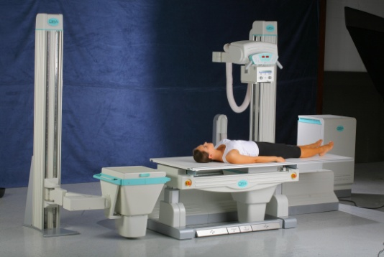

In a hospital, a new digital X-ray imaging system is being used to replace photographic film. In the digital system, X-rays are detected by sensors and an image displayed on a computer screen.

Photographic film, which contains silver, is expensive and hazardous chemicals are used to develop the film. The digital system is less expensive, does not use hazardous chemicals and the X-ray image is obtained in a shorter time.

(*i*) Using information **given in the passage** state **two** advantages of the digital X-ray imaging system.

|  |
| --- |
| Advantage 1  Advantage 2 |

**Passage 9**

**Read the following passage and answer the questions based on it.**

**Alexis St. Martin – Human Guinea Pig**

In 1822, a 20 year old Canadian fur trapper called Alexis St. Martin was accidentally injured by a shotgun. His abdomen and stomach were blasted open. He survived thanks to prompt treatment by a local doctor. His stomach did not fully heal and Alexis was left with an opening to his stomach which the doctor covered with a leather flap.

The doctor was a keen scientist and carried out more than 60 experiments on his patient. In one experiment he tied lumps of food to a silk thread and pushed them into Alexis’ stomach. Each hour he pulled them out to see what the stomach juices had done to the food, carefully recording the results. A piece of boiled beef was half the original size after 1 hour and completely gone after 2 hours. A piece of raw beef was digested in exactly the same

manner.

In another experiment, the doctor removed some of the digestive juices from Alexis’ stomach and put them into a glass tube. A piece of boiled beef was put into the tube and kept at body temperature. It showed little change after 1 hour, was only half gone in 2 hours and disappeared after 4 hours.

Despite his injuries Alexis led a long and healthy life. He married and had six children. He survived to the age of 86, outliving the doctor by many years.

(*a*) What was the purpose of the silk thread?

|  |
| --- |
|  |

(*b*) Why did the doctor keep the experiment in the glass tube at body temperature?

|  |
| --- |
|  |

(*c*) How long did Alexis live after the shotgun accident?

|  |
| --- |
| *Space for calculation*  *Answer:* years |



(d) Complete the table of   
results using the information   
in the passage

**Passage 10**

**Read the following passage and answer the questions based on it.**

The term “raptor” refers to birds of prey. This group includes diurnal types (such as hawks, eagles, falcons and vultures) which feed in daylight. It also includes nocturnal types (such as owls) which feed mostly at night.

With the exception of the vultures, which feed on the leftovers other hunters leave behind, all of the raptors use their feet to catch and kill their prey. Many falcons have an elongated middle toe which they wrap around the prey while still in flight. Hawks’ feet have a ratchet-like mechanism to aid capturing and holding their prey without too much exertion. Once the toes

and talons have tightened around the prey, they remain locked in place without further effort.

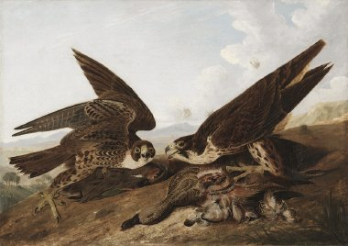  
Raptors are completely carnivorous, obtaining all of their required nutrients from their prey. The nutrients which normally come from vegetable matter are often found in the stomachs of their prey. A lot of the water required for survival is also extracted from the prey. Raptors devour the prey entirely, regurgitating the indigestible matter in pellet form once or twice a day.

All of the raptors have hook-tipped beaks which are used for ripping the dead prey. Falcons have a notch on each side of the upper beak forming a tooth-like projection, while some hawks have a more prominent hooked tip to the beak, probably for a similar reason. Vultures have developed a much larger, stronger beak for tearing the hides of dead animals and cracking their bones.

(*a*) Describe the main difference, mentioned in the passage, between hawks and owls.

|  |
| --- |
|  |

(*b*) Describe the feeding habits of vultures which make them different from other raptors.

|  |
| --- |
|  |

(*c*) Explain how raptors can obtain vitamins and minerals found only in plants, even though  
 they are entirely carnivorous.

|  |
| --- |
|  |

(*d*) Describe **two** differences mentioned in the passage between falcons and hawks.

|  |
| --- |
| 1 Falcons  Hawks  2 Falcons  Hawks |

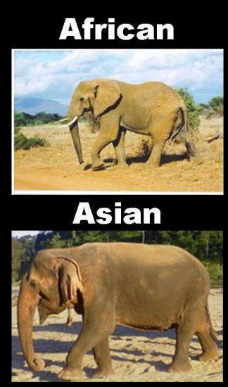**Passage 11**

**Read the following passage and answer the questions based on it.**

The African elephant is the largest living land animal, with males reaching a height of 4.5 metres and a weight of up to 7 tonnes. Their ears are large and fan shaped. Tusks are present in both males and females. Asian elephants have smaller ears which are straighter along the bottom. These elephants weigh up to 5 tonnes and grow to a height of 4.0 metres. Tusks are found on only a few male Asian elephants and none of the females.

Elephants can live for up to 70 years. They generally form small family groups of mothers and young. Males leave the herd at puberty. Female elephants are capable of giving birth every four to six years. Calves are born 22 months after fertilisation and are on average 1 metre tall. They are weaned from their mothers’ milk between the ages of two and four years. After this time their diet consists of tree branches, fruits and grass.

Elephants were hunted for their tusks which are made of ivory. Ivory can be carved into objects of value. Trading in ivory is now illegal but elephants continue to be killed by poachers for their tusks.

About 16 000 domesticated elephants are kept as work animals for such activities as clearing logs, transporting heavy loads and carrying tourists. Elephants can work in areas where machinery cannot go. However, areas of natural forest have decreased considerably due to

human activity. This has resulted in less logging work which is the main occupation of domestic elephants.

(*a*) Describe three differences between African and Asian elephants.

|  |
| --- |
|  |

(*b*) Why are the adults in an elephant family group all females?

|  |
| --- |
|  |

(*c*) (i) Why are elephants sometimes killed by poachers?

|  |
| --- |
|  |

(ii) Elephant poaching is less of a problem in Asia than in Africa.

Suggest a reason for this.

|  |
| --- |
|  |

(*d*) Suggest a reason why the number of domesticated elephants may be decreasing.

|  |
| --- |
|  |

**Passage 12**

**Read the following passage and answer the questions based on it.**

***Bugs R Us***

If we are not using our mouths to chew or swallow food, we are talking, drinking or brushing our teeth. Even so, some microbes do manage to hang on in there. Most of the time they do no harm but sometimes they can cause problems. The worst of these is a gum disease called peridontitis. This is the most widespread infectious disease in humans.

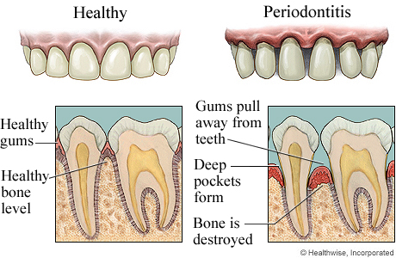

Peridontitis begins when bacteria, which are normally harmless, are allowed to build up. They form a sticky layer of plaque at the junction of the teeth and gum. This provides ideal conditions for anaerobic bacteria to grow. These bacteria produce enzymes which can break down the surrounding gum tissue. This causes inflammation which can eventually weaken the jawbone in which the teeth are held. People over thirty are more likely to lose teeth through this type of gum disease than through the formation of cavities in the teeth.

Cavities are formed when particular bacteria in the plaque use sugary food in the mouth for energy. They do this without using oxygen, producing lactic acid as a waste product. This acid attacks the enamel of the tooth, resulting in cavities.

(*a*) Give **three** examples of activities from the passage which could make it difficult for  
 bacteria to live in the mouth.

|  |
| --- |
| 1  2  3 |

(*b*) Where in the mouth would you expect to find high levels of anaerobic bacteria growing?

|  |
| --- |
|  |

(*c*) Which type of chemical attacks the gums in peridontitis?

|  |
| --- |
|  |

(*d*) Name **one** harmful condition mentioned in the passage, other than peridontitis, which   
 results from the activity of bacteria.

|  |
| --- |
|  |

**Passage 13  
Read the following passage and answer the questions based on it.**

Halley’s Comet is famous because it is visible to the naked eye, orbiting from beyond the planet Neptune and returning to the solar system on average once every 76 years.

Halley’s Comet last visited the inner solar system in 1986. It will return again in 2061.

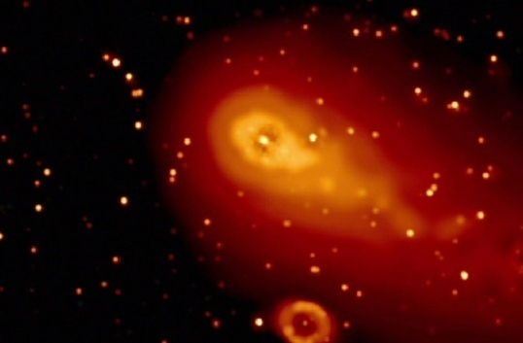Comets are made of ice mixed with frozen methane; substances very similar to those found on a moon called Miranda. Comets can only survive very far away from the Sun. Most comets reside in the Oort Cloud which contains many billions of comets.

The Oort Cloud reaches a quarter of the distance from the Sun to the next nearest star called Proxima Centauri.

The Oort Cloud is easily affected by the gravitational pull of the Milky Way galaxy which causes comets to move into new orbits that carry them closer to the Sun.

Use information **given in the passage** to answer the following questions.

(i) State the name of **one** object that orbits a planet.

|  |
| --- |
|  |

(ii) State the name of **one** object that generates light.

|  |
| --- |
|  |

(iii) State the name of the object furthest away from the Earth.

|  |
| --- |
|  |

(iv) State the name of **one** object that orbits the Sun.

|  |
| --- |
|  |

**Passage 14  
Read the following passage and answer the questions based on it.**

**Fight for your Life!**

Adapted from *Biological Sciences Review*, September 2005

Every day there is a battle inside our bodies between invading micro-organisms and our immune system. Bacteria are present inside and out. Most are harmless but others are pathogens which cause disease. Infectious diseases are a major killer in developing countries.   
  
Vaccination programmes, public health improvements and increasing the availability of antibiotics are required to overcome them. However, there is a growing problem of resistance to antibiotics demonstrated by the “superbug” MRSA.

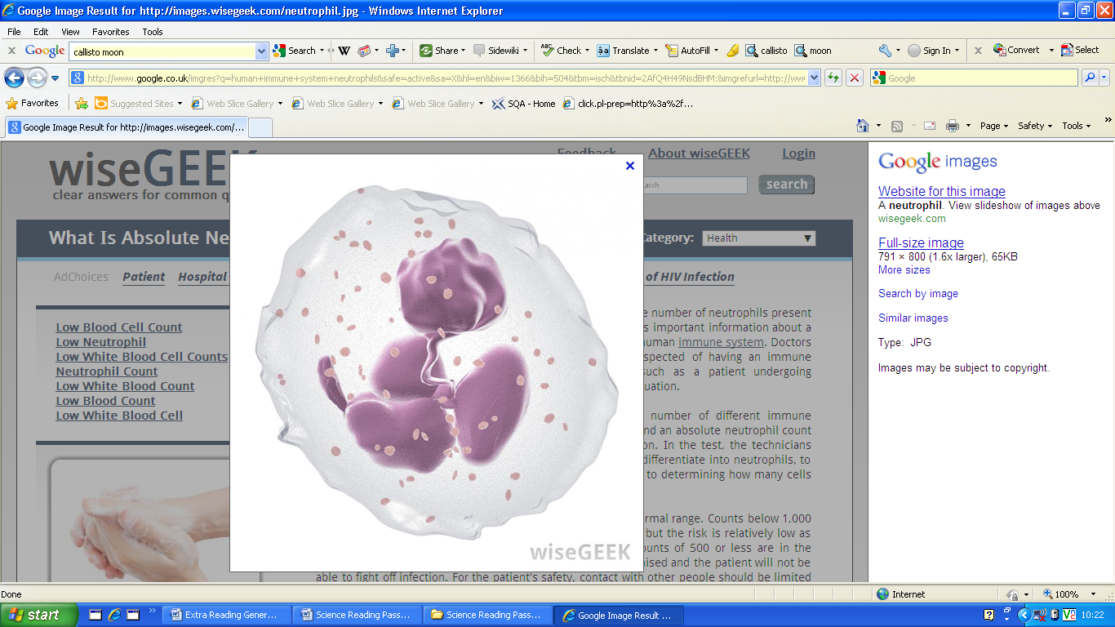The first thing a micro-organism does is to find its way into a cell in the body. Cells of the immune system have to recognise that this has happened and make the appropriate response. The first cells on the scene are **neutrophils**. They engulf bacteria and kill them with enzymes. The next cells to arrive are macrophages which have a variety of specialised killing mechanisms. Dendritic cells are also involved. They are able to recognise pathogens and stimulate other immune cells to react.

Fortunately, our immune system has a memory. This means that when we encounter a micro-organism for the second time, a much faster response is triggered that rapidly wipes out the pathogen. Our immune system is very powerful, giving us the best chance to win the battle with these invaders. Sometimes this system breaks down and immune cells wrongly target and destroy our own body cells. This causes conditions such as rheumatoid arthritis and

multiple sclerosis.

(*a*) What name is given to micro-organisms such as bacteria which cause disease?

|  |
| --- |
|  |

(*b*) Give **three** actions which are needed by developing countries to overcome infectious  
 diseases.

|  |
| --- |
| 1  2  3 |

(*c*) Why is MRSA a growing problem?

|  |
| --- |
|  |

(*d*) Name **three** types of immune cells involved in a response to an attack by

invading micro-organisms.

|  |
| --- |
| 1  2  3 |

(*e*) Why is the response of the immune system faster the second time a type of micro-  
 organism invades?

|  |
| --- |
|  |

(*f*) What causes conditions such as rheumatoid arthritis?

|  |
| --- |
|  |

**Passage 15  
Read the following passage and answer the questions based on it.**

**Twins**

Multiple births have been on the rise with increasing numbers of twins being born. There are several reasons for this, including the growing use of fertility drugs and the fact that more older women are having babies. Between 1996 and 2006 there was a 182% increase in multiple births in women aged 35 and over. About 1·25% of births from natural conception results in twins, but this increases to 25% if fertility drugs are used.

Twins can be identical or non-identical. An ultrasound scan can help to determine which is the case. If the babies develop together in a single sac with no separating membrane, or share one placenta, they are likely to be identical. Identical twins will always be the same sex because they carry the same genetic information. However, the only sure way to tell if twins are

identical is to have a DNA test.

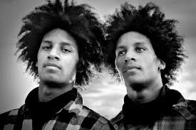The chance of having identical twins is about 1 in 250 births. The chance of having non-identical twins varies according to whether there is a history of non-identical twins in the mother's family. If there is, she is more likely to have them. About 33% of all twins born are identical. They are formed when one egg is fertilised by one sperm and then the zygote divides into two halves which develop separately. Non-identical twins form when two eggs are fertilised by two different sperm.

(*a*) Give **two** reasons for the increase in the number of twins being born.

|  |
| --- |
| 1  2 |

(*b*) Give **two** pieces of evidence from an ultrasound scan that would suggest that twins are  
 identical.

|  |
| --- |
| 1  2 |

(*c*) What is the only sure way to tell whether or not twins are identical?

|  |
| --- |
|  |

(*d*) How do identical twins form?

|  |
| --- |
|  |

(*e*) What percentage of all twins are **non-identical**?

|  |
| --- |
|  |

(*f*) Which parent's family history has more influence on the chance of having non-identical  
 twins?

|  |
| --- |
|  |